**Optimization Techniques**

**NAME**: TITHI PATEL

**ENROLLMENT NUMBER: 18BECE30558**

**5 TH SEM CE SHIFT 2**

**PRACTICAL 16 and 17** Write a function for Newton Raphson and Secant Method.

--------------------------------------------------------------------------------------------------------------------------

**Newton Raphson**

function [] = nf(f,df,a)

x=a;

for i=1:1:100

x1=x-(f(x)/df(x));

x=x1;

endfor

root=x;

fprintf('Approximate root is %.15f',root);

endfunction

**OUTPUT:**

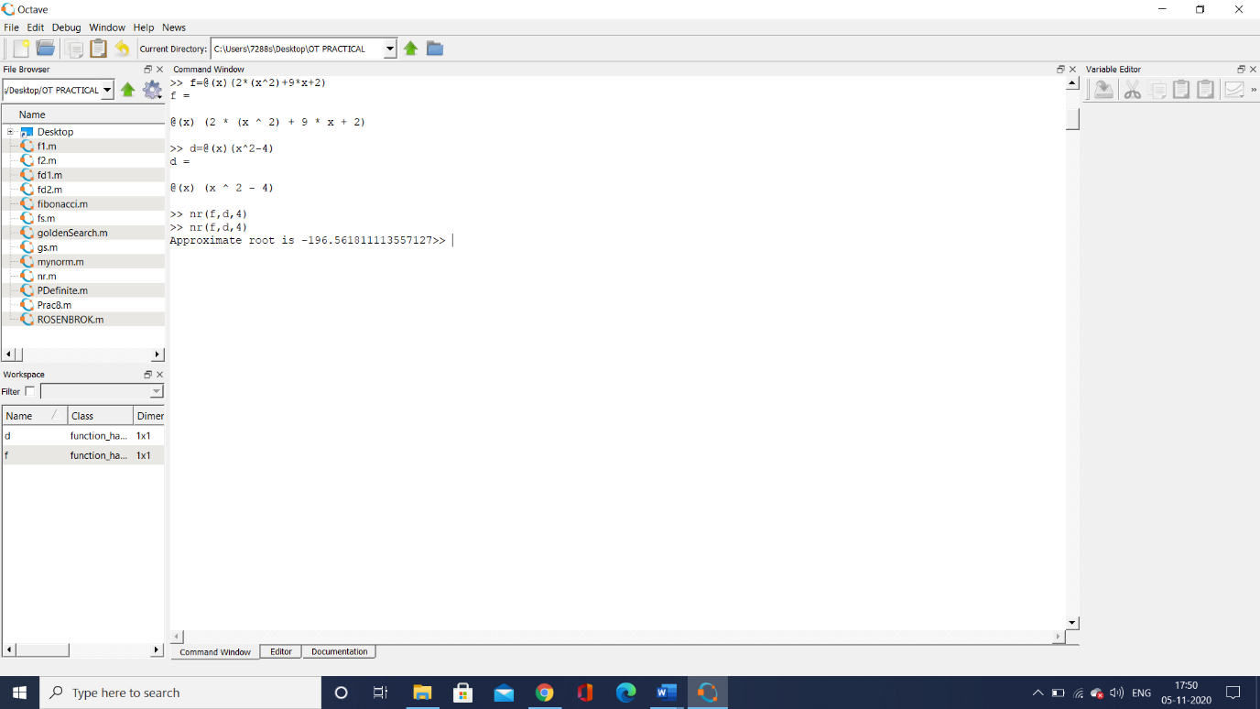

--------------------------------------------------------------------------------------------------------------------------------------

**Secant Method**

function [] = sec(f, x0, x1, eps)

f_x0 = f(x0);

f_x1 = f(x1);

no_of_iterations = 0;

while abs(f_x1) > eps &&no_of_iterations < 100

try

denominator = (f_x1 - f_x0)/(x1 - x0);

x = x1 - (f_x1)/denominator;

catch

fprintf('Error! - denominator zero for x = \n', x1)

break

end

x0 = x1;

x1 = x;

f_x0 = f_x1;

f_x1 = f(x1);

no_of_iterations =no_of_iterations + 1;

end

if abs(f_x1) > eps

no_of_iterations = -1;

end

solution = x1;

no_iterations =no_of_iterations;

if no_iterations > 0

fprintf('Number of function calls: %d\n', 2 + no_iterations);

fprintf('A solution is: %f\n', solution)

else

fprintf('Stop execution')

end

end

**OUTPUT:**

